
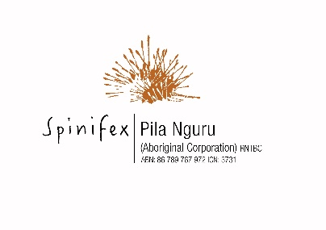
Spinifex Media Permit A
Application Form

This permit applies to Journalists or news organisations producing news of the day or current affairs

The permission of Anangu (Spinifex / Untiri Pulka Native Title holders) is required to enter or remain on Spinifex country in and around Tjuntjuntjara; specifically, within the Untiri Pulka and Spinifex native title determination areas.
Pila Nguru Aboriginal Corporation (Pila Nguru) is authorised to issue Media Permits in the region to ensure compliance with all relevant laws, in consultation with Paupiyala Tjarutja Aboriginal Corporation (PTAC) where necessary.
All approved Media Permit holders will be required to pay a one-off application fee of $50 prior to receiving your Approved Permit. Pila Nguru will be in touch with your regarding the payment, on receipt of this form.
The Spinifex Media Permit A applies to the areas in orange in the below Map
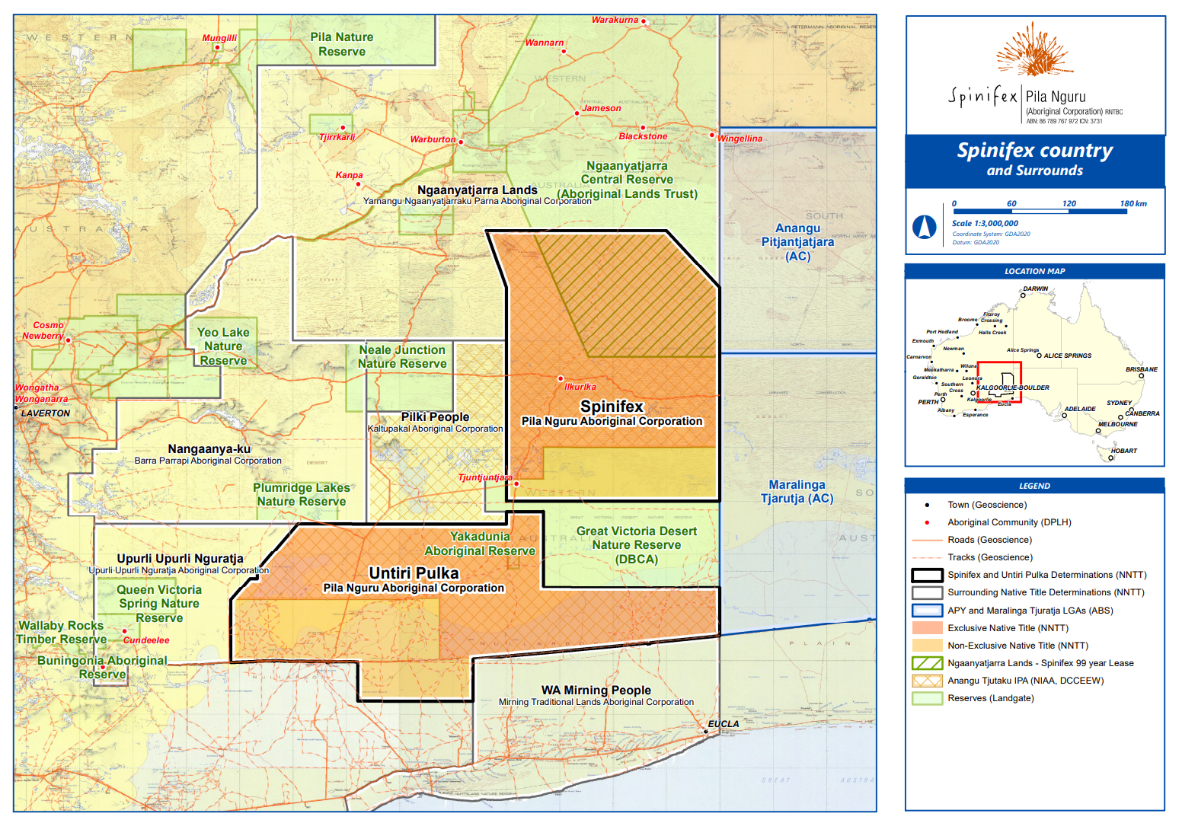

GENERAL CONDITIONS ON MEDIA PERMITS
- This Media Permit and authority is issued on the basis that all persons to whom it is issued enter the Untiri Pulka and Spinifex native title determination areas at their own risk and agree that neither PTAC, Pila Nguru nor the landowners or occupiers shall be liable either jointly or severally for any loss, damage or liability of any kind arising out of or in relation to the entry of the holders onto the Untiri Pulka and Spinifex native title determination areas no matter how such loss, damage or liability arises whether by fault or default or negligence.

- This Media Permit and authority is issued subject to the general conditions contained in this application and any special conditions specified in this authority. This Media Permit and authority is automatically revoked if any general or special condition is breached by the holder.

- This Media Permit and authority is issued on the condition that the holder follows all directions of Anangu whilst on the Untiri Pulka and Spinifex native title determination areas.

- This Media Permit and authority is issued on the condition that the holder has read, understands, and will comply with the Tjuntjuntjara Media Policy (provided).

- This Media Permit and authority does not authorise the entry of a person to a dwelling or a living area or a camp occupied by or belonging to Anangu without the consent of the owner or occupier.

- This Media Permit and authority may be revoked at any time.

- This Media Permit and authority does not authorise the holders to carry or discharge a firearm, operate a drone, or take photographs while on the Untiri Pulka and Spinifex native title determination areas unless specified.

- This Media Permit and authority is valid only to enable the holders to perform the duties or activities associated with the stated purpose of the visit.

- This Media Permit and authority must be always carried while the holder is on the Untiri Pulka and Spinifex native title determination areas and must be produced for inspection on demand.

- Liquor must not be brought into the Untiri Pulka and Spinifex native title determination areas.

- With the exception of Opal*, petrol must not be brought onto the Untiri Pulka and Spinifex native title determination areas, whether in vehicle tanks, jerry cans, fuel drums or otherwise. *Opal petrol is a BP product designed to reduce harm caused by petrol sniffing.

- This Media Permit will not allow you to enter the Untiri Pulka and Spinifex native title determination areas for any purpose other than stated on the Media Permit.

- I have read the above general conditions and understand them. I agree to abide by these conditions and any special conditions that may be set out on the Media Permit. The information contained in this application is true and correct.

Applicant’s signature

- Applicant details:

Company name:
Applicant’s full name:
Applicant’s role / position:
Phone number:
Website:
Email address:
Street Address:

- Additional people to appear on the Entry Permit

Additional person #2
Additional person #3
Additional person #4
Additional person #5
Additional person #6

- Dates of visit

- Project Description

Project Medium
(TV, radio, internet, etc)

Project planned/proposed distribution
(outlets for products, extent of exposure and number of copies. Please include information regarding planned social media usage in relation to the project)

Details of any proposed filming of Anangu, their living areas or other aspects of their culture

What is the subject / storyline/ content? Include details of any specific people, locations and issues to be covered (please attach a map with this application if location is outside of Tjuntjuntjara)

Names and contact details of people already contacted

Details of any local assistance required, such as guides and interpreters

Are requesting permission to use a drone? If yes, please provide details

- Benefits

Does your project offer any employment and training opportunities for Anangu?

- Copies and Copyright

Will you share copyright of your images and recordings with Anangu (via PTAC or Pila Nguru?)

Will you supply copies of your photos or recordings to relevant Anangu archives (via PTAC or Pila Nguru) or individuals?

- Accommodation (please specify)

- Planned Access
Please specify which roads you are wishing to use to travel in and out of Spinifex country

- Vehicle details
Make
Colour
Registration
State registered

Please submit this completed form as a PDF to access@spinifex.org, along with any supporting documentation such as other Permits required as part of your planned journey.
Please note: PTAC may be called upon to assist travellers requiring rescuing on roads in Spinifex country, however the costs incurred will be recouped from the traveller.
The Pila Nguru Board of Directors (and possibly the PTAC Board of Directors) may need to be consulted on this Entry Permit application and will respond to your application as soon as is practicable.
Please note this is not a self-issued permit and requires you to have a current email address (as provided above).

