**Spinifex Entry Permit**

**Application Form**

**This permit applies to:**

1. Anyone travelling through Spinifex country on non-public roads
2. Air and road transport operators
3. Non-government Contractors with an authorised work purpose (such as telecommunication, road, civil and capital works and maintenance personnel)
4. Government subcontractors
5. Visitors staying overnight or longer in Tjuntjuntjara or on surrounding Spinifex country, including immediate family members of individuals who are living and working in Tjuntjuntjara.

**The permission of *Anangu* (Spinifex / Untiri Pulka Native Title holders) is required to enter or remain on Spinifex country in and around Tjuntjuntjara; specifically, within the Untiri Pulka and Spinifex native title determination areas.**

**Pila Nguru Aboriginal Corporation (Pila Nguru) is authorised to issue Entry Permits in the region to ensure compliance with all relevant laws, in consultation with Paupiyala Tjarutja Aboriginal Corporation (PTAC) where necessary.**

All approved Permit holders will be required to pay a one-off application fee of $50 prior to receiving your Approved Permit. Pila Nguru will be in touch with your regarding the payment, on receipt of this form. **Application fees do not apply to staff working in Tjuntjuntjara and their family members.**

**The Spinifex Entry Permit applies to the areas in orange in the Map below**

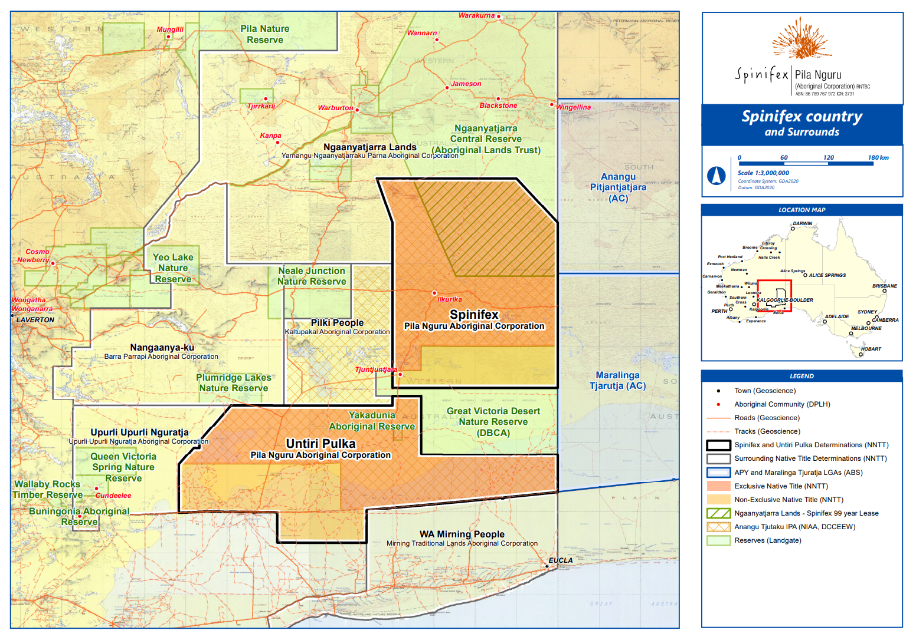

|  |  |  |  |  |  |  |  |  |  |  |  |  |  |  |  |  |  |  |  |  |  |  |  |  |  |  |  |  |  |  |  |  |  |  |  |  |  |  |  |  |  |  |
| --- | --- | --- | --- | --- | --- | --- | --- | --- | --- | --- | --- | --- | --- | --- | --- | --- | --- | --- | --- | --- | --- | --- | --- | --- | --- | --- | --- | --- | --- | --- | --- | --- | --- | --- | --- | --- | --- | --- | --- | --- | --- | --- |
| 1. **Applicant details:**  |  |  | | --- | --- | | Company name: |  | | Applicant’s full name: |  | | Applicant’s role / position: |  | | Phone number: |  | | Website: |  | | Email address: |  | | Street Address: |  |  1. **Additional people to appear on the Entry Permit**  |  |  | | --- | --- | | Additional person #2 |  | | Additional person #3 |  | | Additional person #4 |  | | Additional person #5 |  | | Additional person #6 |  | |  |  |  1. **Are you intending to take photographs, make audio or visual recordings or use a drone during your visit?**  |  | | --- | | ***If yes, you will need to apply for a Media Permit B instead of an Entry Permit. This can be downloaded from Pila Nguru’s website.*** |      1. **Purpose of visit**  |  | | --- | |  |  1. **Dates of proposed visit**  |  | | --- | |  |  1. **Accommodation (please specify)**  |  | | --- | | ***Please note that Bookings at the Ilkurlka Roadhouse and the Barn (in Tjuntjuntjara) need to be made directly with PTAC once your Entry Permit is issued.*** |  1. **Planned Access**   **Will you be accessing Spinifex country by road?**   |  | | --- | | ***If yes, please specify which roads you are wishing to use to travel in and out of Spinifex country.*** |   **Will you accessing Spinifex country by aircraft?**   |  | | --- | | ***If yes, please note that you will need to liaise directly with PTAC regarding access to the airstrip once your Entry Permit is issued.*** |  1. **Vehicle details**  |  |  | | --- | --- | | Make |  | | Colour |  | | Registration |  | | State registered |  |  1. **Names and contact details of people already contacted regarding your visit**  |  | | --- | |  |      1. **Details of any local assistance required, such as guides and interpreters**  |  | | --- | |  |   Please submit this completed form as a PDF to access@spinifex.org, along with any supporting documentation such as other Permits required as part of your planned journey.  Please note: PTAC may be called upon to assist travellers requiring rescuing on roads in Spinifex country, **however the costs incurred will be recouped from the traveller**.  The Pila Nguru Board of Directors (and possibly the PTAC Board of Directors) may need to be consulted on this Entry Permit application and will respond to your application as soon as is practicable.  Please note this is not a self-issued permit and requires you to have a current email address (as provided above). |